
Nine Whys
Make the Purpose of Your Work Together Clear (20 min.)
If you want to build a ship, don’t drum up people to collect wood and don’t assign them tasks and work, but rather teach them to long for the endless immensity of the sea. Antoine de Saint-Exupery
What is made possible? With breathtaking simplicity, you can rapidly clarify for individuals and a group what is essentially important in their work. You can quickly reveal when a compelling purpose is missing in a gathering and avoid moving forward without clarity. When a group discovers an unambiguous shared purpose, more freedom and more responsibility are unleashed. You have laid the foundation for spreading and scaling innovations with fidelity.
Five Structural Elements – Min Specs
1. Structuring Invitation
- Ask, “What do you do when working on ______ (the subject matter or challenge at hand)? Please make a short list of activities.” Then ask, “Why is that important to you?” Keep asking, “Why? Why? Why?” up to nine times or until participants can go no deeper because they have reached the fundamental purpose for this work.
2. How Space Is Arranged and Materials Needed
- Unlimited number of groups
- Chairs for people to sit comfortably face-to-face; no tables or equipment needed.
3. How Participation Is Distributed
- Everyone has an equal opportunity to participate and contribute
4. How Groups Are Configured
- First pairs, then groups of four, then the whole group (2-4-All)
5. Sequence of Steps and Time Allocation
- Each person in a pair is interviewed by his or her partner for 5 minutes. Starting with “What do you do when working on ____?” the interviewer gently seeks a deeper answer by repeating the query: “Why is that important to you?” Switch roles after 5 minutes. 10 min.
- Each pair shares the experience and insights with another pair in a foursome. 5 min.
- Invite the whole group to reflect by asking, “How do our purposes influence the next steps we take?” 5 min.
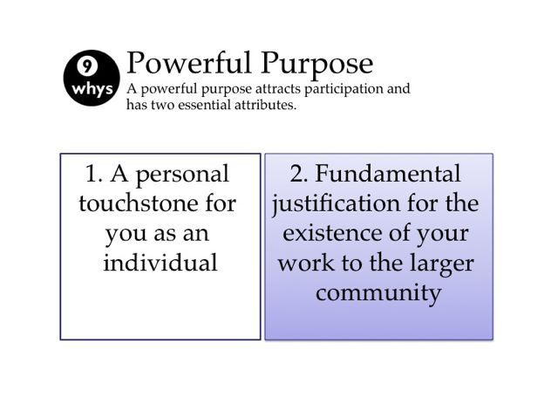
He who has a “why” can endure any “how.” Friedrich Nietzsche

WHY? Purposes
- Discover what is truly important for the group members
- Lay the groundwork for the design that will be employed
- Ignite organizational momentum through the stories that emerge
- Generating a small number of clear answers can help you move forward together with more velocity
- Provide a basis for progressive evaluation
- Generate criteria for deciding who will be included
Tips and Traps
- Create a safe and welcoming space; avoid judgments
- Have fun with it: you can invite participants "to channel their inner toddler" while they ask why repeatedly
- Keep going! Dig deep with compassion. Vary the ways of asking “why?” For example, ask, “If last night, while you slept, your dream came true, what would be different?”
- Make sure the question asked is, “Why is it important to YOU?” (meaning not THE amorphous organization or system but you personally)
- Share the variety of responses and reflect on differences among group members. What common purpose emerges?
- If someone gets stuck ask, “Does a story come to mind?”
- Maintain confidentiality when very personal stories are shared
- Make clarifying purpose with Nine Whys a routine practice in your group
Riffs and Variations
- Combine a short Appreciative Interview with Nine Whys. Start with the interview, then ask: "why is the success story you have shared important to you? Why, Why, Why?"
- Ask the small groups whether “a fundamental justification for committing time and money to the work” emerged in the conversation. A clear personal purpose plus a community justification can quickly fuel the spread of an initiative. Work toward a single sentence that powerfully justifies the group’s work to others: “We exist to…! or We exist to stop...!”
- In a business context, ask, “Why would people spend their money with you? Why would leaders want you to operate your business in their country?”
- Add 10 how questions after you have clarity around why (it becomes MUCH easier).
- A good purpose is never closed. Make it dynamically imcomplete by inviting everyone to make contributions and mutually shape understanding of the deepest need for your work.
- Record answers on Post-it notes, number them, and stick on a flip chart. You can arrange the answers in a triangle: broad answers on the top and detailed answers on the bottom. Compare and debrief.
- Ask, “Why is that important to your community?” “Why? Why? Why?…”
- Use the chat function during a webinar to start formulating a purpose statement: participants reflect on the Nine Whys questions, sharing their ideas in the chat box.
- Link to Purpose-To-Practice; Generative Relationships; Wise Crowds; What, So What, Now What? and many other Liberating Structures.
Examples
- For crafting a compelling shared purpose to launch a collaborative research organization. The Quality Commons, a health-service research network composed of representatives from seven health systems across the United States, used Nine Whys as one step in the Purpose-To-Practice Liberating Structure.
- For the beginning of any coaching session, including Troika Consulting or Wise Crowds.
- For clarifying the purpose behind the launch of a new product.
- For anchoring each element of a Design Storyboard by asking, “Why is this activity or element important to you? What does it add to the flow of exchanges among participants?”
- For you as an individual to clarify your personal purpose
Attribution: Liberating Structure developed by Henri Lipmanowicz and Keith McCandless. Inspired by Geoff Bellman, author and consultant.
Collateral Materials
Below: Presentation materials we use to introduce Nine Whys
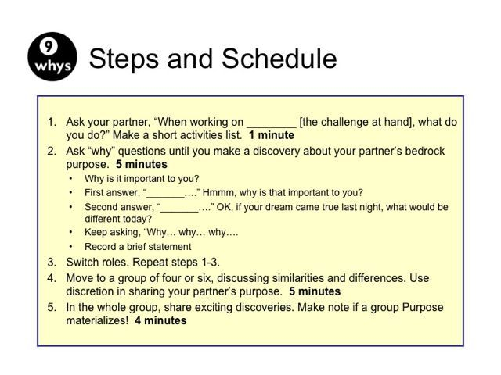
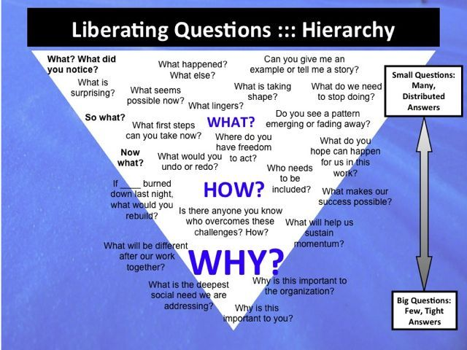“Why” questions are at the base because they dig for the essence of or deepest need for your activities. Generating a small number of clear answers can help you move forward together with more velocity.

