Therapeutic Discord

While some level of misunderstanding is inevitable in all human relationships, including treatment relationships, more severe misunderstandings are frequent in patients seeking our help. For many of our patients, discord and subsequent mistrust is common both in the office and in their day-to-day lives. Commonly, unresolved histories of relationship trauma, childhood neglect, magnify the intensity of discord. In the treatment alliance, trust may make an appearance, but it is fragile and must be continuously rebuilt and repaired. The goal in this workshop is to embrace discord and improve our capacity for repair. The framework used will be based on mentalization-based therapy.
The literature on rupture defines it as a break in the treatment alliance such that trust deteriorates, often impairing any further therapeutic progress. It is often accompanied by a noticeable change in affect. Common causes include disagreements in the purpose or methods of treatment, misalignment in expectations. Examples that come to mind include completing forms or letters, demanding or refusing hospitalization, expecting specific medications, requests for more or sooner therapist or physician time, conversations about drug use, responses to treatment interfering behaviors. The empiric literature on rupture is clear. Unaddressed rupture leads to poor outcomes or dropouts, whereas repair of rupture leads to improved outcomes. Repaired rupture is more alliance building than no rupture and repair at all. While rupture captures a severe breakdown in trust, I’m using the word “discord” to describe an intermediate state of relationship tension before a full rupture. I also highlight this intermediate step to encourage moment-to-moment awareness of misalignment. In these moments, we have more chances to engage and repair before full rupture appears.
Research into treatment alliance rupture identifies both withdrawal and confrontation as behavioral responses to rupture. Confrontation is easily identifiable. It often is accompanied by strong affect and arousal. Withdrawal may be overt but is often more subtle, sometimes appearing as disinterest or a loss of affective engagement in the office. It may also be acted out. Missing subsequent appointments, disengaging more broadly in treatment, or engaging in talk peripheral to treatment goals all may reflect withdrawal discord or rupture. Within the DBT literature, some of these behaviors are also described as treatment interfering behaviors. Withdrawal may also lead to appeasement, and along with it, relatedness is valued more than self-definition.
Both the current context as well as attachment and developmental forces shape patients' behaviors when discord emerges. Insecure, anxiously attached patients experience elevated levels of autonomic arousal specifically when attachment stress develops. Behaviorally, this more likely is accompanied with high affect confrontation when alliance discord develops. In contrast, avoidant, insecurely attached patients are more likely to engage in withdrawal. Disorganized attachment may include a mixture of both avoidance and withdrawal. The graph below demonstrates differences in physiologic arousal between anxiously attached and avoidantly attached patients when undergoing relationship stress.
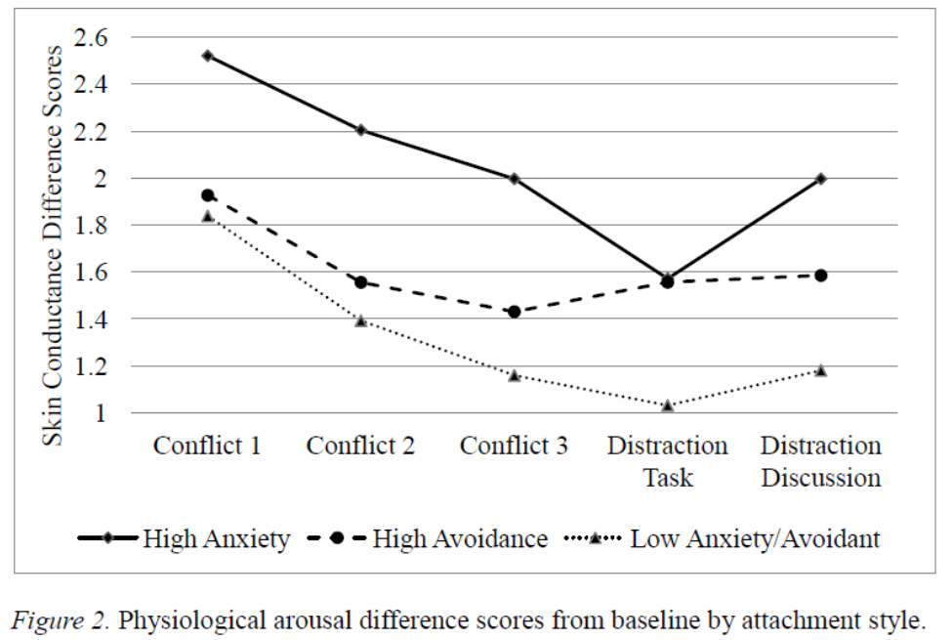

Discord can also be understood by considering mental states. Specifically, the way in which our minds understand what is happening in the mind of others and ourselves. This mental skill, “mentalization”, will inform our assessment of discord and subsequent interventions. Rapid, implicit, and often very certain mentalization appears during highly stressful discord, whereas slower, explicit, and more flexible understanding occurs in lower arousal discord.
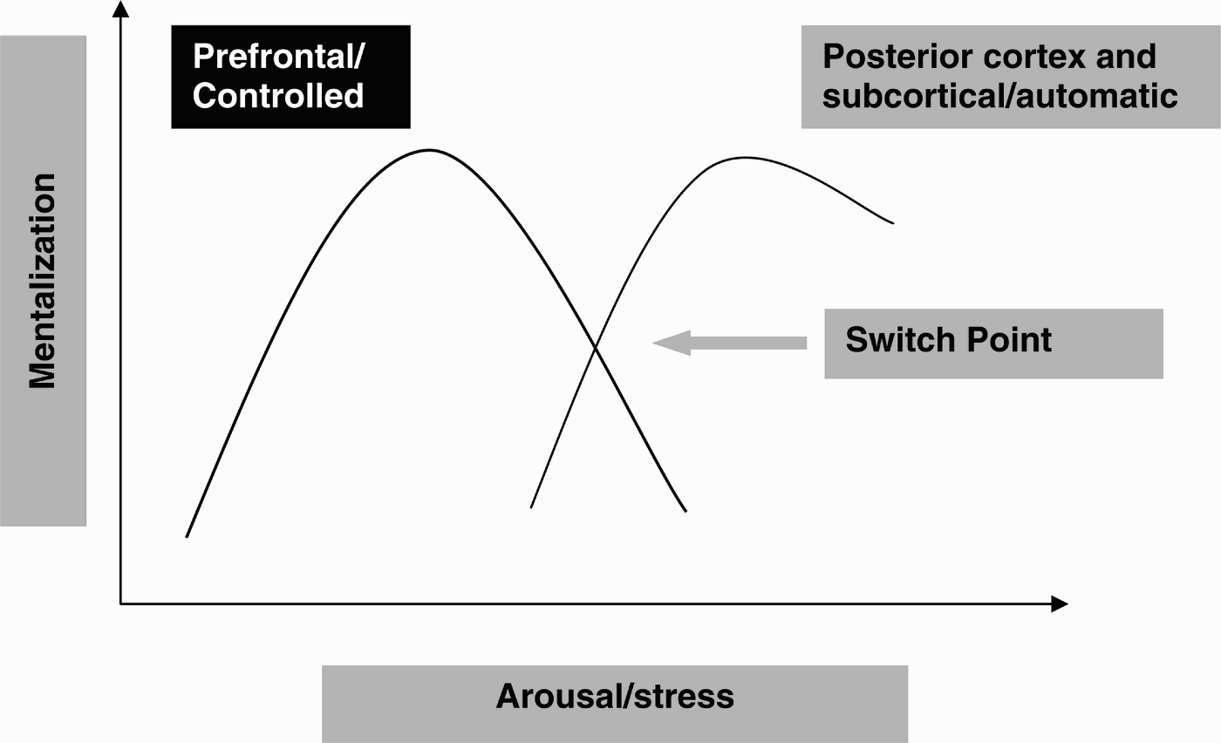
These different types of mentalization correspond to different brain locations. As you might expect, prefrontal mentalization is more likely under situations of lower stress and arousal. As the level of discord increases, slower, controlled prefrontal processes start to go off line, and faster, much more certain but uncontrolled subcortical understanding dominates.
All of us in this workshop have experiences where we were wildly misunderstood and could not quickly regain some reasonable shared understanding of what was said or done. I’m reminded of an appointment where I threw away a coffee cup while the guardian (aunt) of a child patient was talking. It was a problem filled conversation about her experiences with her niece's behavior. When I threw away my empty coffee cup, she angrily stated that “I was throwing her away” and was certain of this regardless of my confused, apologetic efforts. Alas, I was unsuccessful and she stormed out, niece in tow. Had I then applied what I understood now, I would have a chance, however small, to validate her emotional experience, express curiosity, and ride out the storm with her. The wellbeing of her niece would have formed a natural focus point to pause and reform shared attention.
With reference to Kahneman’s popularization of dual process theory, I’m going to use the shorthand “slow” and “fast” to refer to the different modes of mentalization.
In addition to general stress, fatigue, and anxiety interfering with slow mentalization, there is one particularly potent stressor that rapidly shuts down effective mentalization, attachment stress. High levels of attachment stress, for example feelings of rejection, abandonment, and unmet attachment needs within the treatment relationship itself, can rapidly decrease effective mentalizing and shift into fast, uncontrolled mentalizing In contrast, low levels of attachment enhance mentalization enhance mentalization.
This leads to a paradoxical experience, which all therapists recognize. Some of the sharpest experiences of discord and rupture occur only after the development of a healthy treatment alliance, after trust and accompanying attachment music has been heard.

Part 2

Of interest to us are the amplified cycles of distrust and misunderstanding that emerge when patients move into fast mentalizing because of discord within the treatment alliance. This move, particularly if accompanied by high affect, criticism, or devaluation, heightens tension. If unrecognized or if the therapist engages in counter-therapeutic responses, distrust and hypervigilance is confirmed and amplified, confirming and rooting the quick, however inaccurate, impressions. This cycle also has neurobiologic roots, as there is a natural pull to adapt our mentalization to the mentalization of others. Mentalization (or lack thereof) is contagious. One aspect of therapeutic discord then is staying firmly in slow mentalization, even as it feels as if both external and internal forces push you into fast.

Example

Patient: “Did the nurse tell you about my sleep? I just need my seroquel upped.”
Physician: “No, I wasn’t informed”
Patient: “I know what works for me, my dose needs to be back where it was.”
Physician: “Are there other things you’d like to talk about today?”
Patient: “Are you not going to increase my seroquel?”
Physician: “I don’t know yet.”
Patient: “I haven’t slept in 3 days and I have to work! If you can’t help me with what I know I need, then I want to speak to a different doctor.”
Physician: “That isn’t how this works”
Patient: “How does it work? I thought I was supposed to get help here.”
Physician: “You’re already on a high dose”
Patient: “Doc, you’re not listening. You’re not listening! The dose I’m on doesn’t work.”
Physician: “Maybe then we should try something else.”
Patient: “When I already know what works? I’m not going to be your guinea pig, doc”
Physician: “I’m not sure what that has to do with this. Your a1c will keep going up, so it doesn’t make sense to increase seroquel.”
Patient: “Ok, I need to see somebody else.”
Physician: “That’s not how this works, you can’t see somebody else immediately and I don’t think they’d instantly give you seroquel either.”
Patient: “Well then I’m going to file a complaint.”
Physician: “About what?”
Patient: “You’re denying me treatment!”
Physician: “I’m not denying you treatment! I’m just explaining…”
Patient: “Ok, it’s whatever you say, you’re the doctor! I’m done”

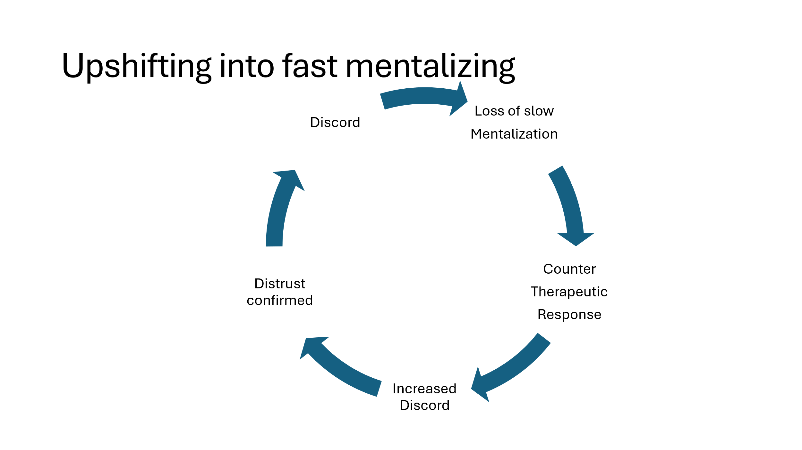

Counter therapeutic responses include using logic or facts, disagreeing, changing topics, providing concrete examples to prove your intentions, going along with a demand, numerous others. Of these, the most common responses I see in psychiatry residents and in other trainees are “going along with the demand” and “changing topics”. None of us are particularly interested in confrontation. Discord often conflicts with the identity we have as nurturing, which may have formed some of our personal reasons to pursue medicine or psychotherapy. This identity is sometimes reinforced by external pressure to ameliorate symptoms, as opposed to offer treatment, two sometimes very different tasks. In the above example, agreeing to increase the Seroquel may have stopped discord in the short term, but it is arguably doing more harm to this patient than good.
Let us imagine a scenario where there were no concerns about diabetes. Increasing Seroquel may still more likely to do more harm than good. How? Patients who frequently engage in confrontation and fast mentalization when under stress very often struggle enormously with healthy relationships. They may shift quickly into fast, inaccurate judgements, undermining trust and over time souring their relationships. The lack of a sustaining relationship is one of the most powerfully depressing and anxiety provoking forces we know of. By “going along” with demands we run the risk of reinforcing behavior that breaks relationships. We hope for a chance, even a small one, for therapeutic discord.
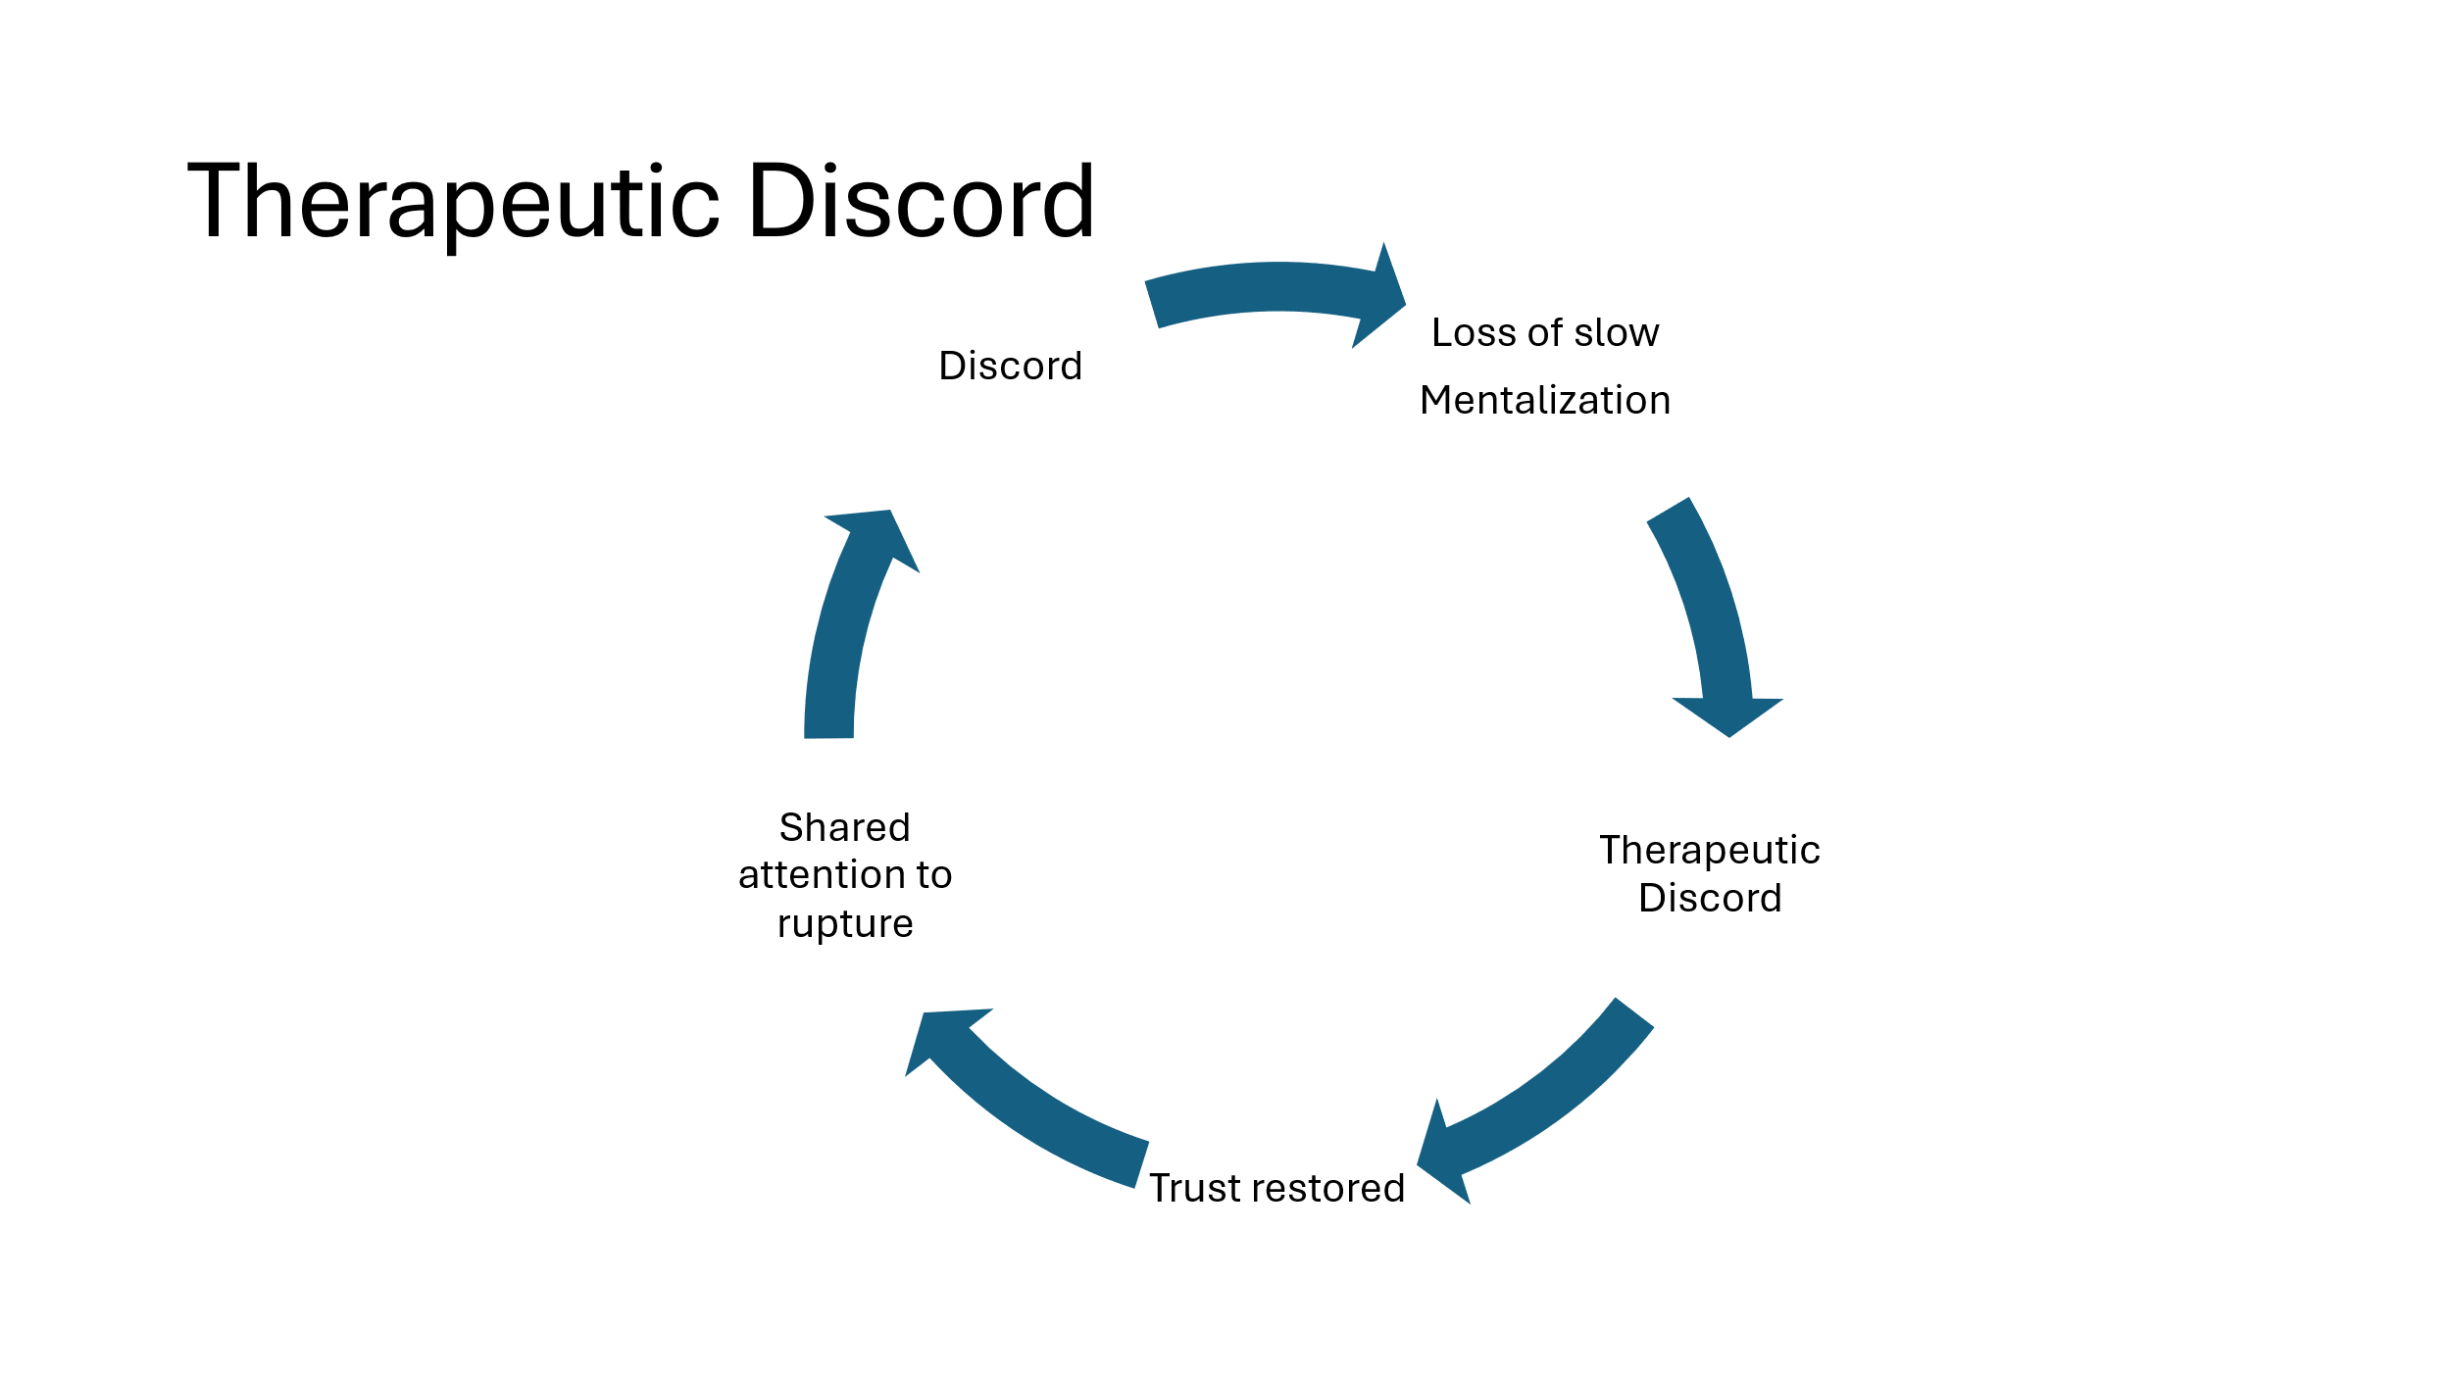
What then are the steps to therapeutic discord? The first step is recognition. Noticing minute by minute discord, and particularly when accompanied by affect changes, helps respond discord before it accelerates. Along with this, it is crucial to identify if the patient has begun to use fast mentalization. Should fast, implicit mentalization appears, the first step is to try to downshift into slow mentalization. A marker of fast mentalization is certainty.
Therapeutic techniques to encourage the return of slow mentalization include.
Engaging attention to the relationship and then;
Empathic Validation
Pausing and Rewinding
Marked reflection of affect
Joining them in the thunderstorm
Entering into a “not knowing” mind
Finally, none of the above can happen unless we remain firmly in slow, careful mentalization ourselves. The challenges to this primarily include fatigue, external pressures of time, and scenarios where strong emotions are generated in ourselves. The workshop will be an opportunity to practice the above.

Ideally, the patient expresses emotion is enthusiastically validated. The most genuine expression of this occurs if you can accurately feel some degree of frustration or anger. This affect is also reflected to them, but in a marked fashion. By this I mean that the emotion is modulated and lightened in your expression. This communicates both that you understand the emotion but maintain the capacity to reflect on it. You are not cognitively fused with it, to use the language of ACT. Long, powerful expressions of discord from a patient should be interrupted, paused. Much like in child therapy, where automatic repetition of a trauma within play must be interrupted, so the fast implicit mentalization must be paused. “I need to pause here and understand” “May I pause and go back so you can help me understand” and so on. These techniques by themselves, repeated, and with patience, often help downshift into slow mentalization.
When we join a patient in the thunderstorm, we accept that the discord that has developed is something that we are in together. It may take the form of empathically stating the patient’s perspective as clearly and clearly as you can. This should be differentiated from accepting a projection.
The “not-knowing”stance.
More than just expressing curiosity, the not-knowing stance accepts that we genuinely do not know the internal experience of another well. Our information, and often the patients’ understanding of themselves, is limited, cloudy. Only through patient listening, using our imagination to explore their experience can we begin to see more clearly. Sometimes the use of a metaphor can help illustrate something that is difficult to put into words and is playful enough to invite editing and additional feedback. “It is like you’re rowing upstream and just then it was like I was an anchor, making it harder. Is that something like it?”
Once slow mentalization is back online, the next step will be to develop shared attention to the discord itself. One hallmark of fast mentalization is that it is certain, oh so certain of what it sees and believes. One hallmark of slow mentalization is that it is willing to consider alternatives and accompanying this, a willingness to engage in a conversation about the discord itself. It may be that you do not have time in one session to do both return to slow mentalization and also reflect on the discord or rupture itself, in which case, you can return to it in following appointments. It is also possible that when you attempt to return to the discord, that this act in particularly sensitive patients, generates tension. It’s worth it to try, particularly if this is a recurring, impairing pattern.
One gentle way to reintroduce discord is to jump into the thunderstorm yourself, accepting responsibility for maintaining a healthy treatment relationship. For example, “I want to talk about last week, because it’s important to me to learn how I can improve the work we do here.” One approach is to develop with the patient a shared history of what happened, of hour the discord developed. This is a time to hear more about what is on their mind, but also to share your own mentalization about your own mind. Some MBT trained therapists use thought bubbles to create a playful atmosphere about this type of work. A last step might be to connect the rupture that has just occurred with broader patterns of relationship stressors.

Samstag, LW, Muran, JC, & Safran, J.D. (2004) Defining and identifying alliance ruptures. In D. Charman (ed) Core processes in brief psychodynamic psychotherapy: advancing effective practice (pp 187-214)
(Eubanks CF, Burckell LA, Goldfried MR. Clinical Consensus Strategies to Repair Ruptures in the Therapeutic Alliance. J Psychother Integr. 2018 Mar;28(1):60-76. doi: 10.1037/int0000097. Epub 2017 Dec 21. PMID: 29805243; PMCID: PMC5966286. ).
Some confrontation from patients may be healthy and reasonable in some situations, although for the purposes of this training, we are interested in treatment interfering confrontation.
Girme, Y. U., Peters, B. J., Baker, L. R., Overall, N. C., Fletcher, G. J. O., Reis, H. T., Jamieson, J. P., & Sigal, M. J. (2021). Attachment anxiety and the curvilinear effects of expressive suppression on individuals’ and partners’ outcomes. Journal of Personality and Social Psychology, 121(3), 524–547
Taylor, Nathan C., "The Relationship between Attachment, Couple Conflict, and Recovery from Conflict" (2014). All Graduate Theses and Dissertations. 4003.
Strifler, Y., & Diamond, G. M. (2025). Mentalization, emotional arousal and readiness to gather information in the context of an ongoing relational rupture. Attachment & Human Development, 27(6), 849–867. https://doi.org/10.1080/14616734.2025.2539276
(Gronchi, G.; Gavazzi, G.; Viggiano, M.P.; Giovannelli, F. Dual-Process Theory of Thought and Inhibitory Control: An ALE Meta-Analysis. Brain Sci. 2024, 14, 101. https://doi.org/10.3390/brainsci14010101 Capraro, V. (2024). The dual-process approach to human sociality: Meta-analytic evidence for a theory of internalized heuristics for self-preservation. Journal of Personality and Social Psychology, 126(5), 719–757. https://doi.org/10.1037/pspa0000375 )
There are other dimensions to mentalizing including cognitive/affective, self/other/relationship, explicit/implicit.
Front. Hum. Neurosci., 26 November 2013Volume 7 - 2013 | Brain mechanisms underlying the impact of attachment-related stress on social cognition
Of note, patients with psychosis spend much of their time in fast mentalization. Schizophrenia in particular, impairs slow deliberate mentalization, although it can improve with practice and with helpful treatment of psychosis. Csulak T, Hajnal A, Kiss S, Dembrovszky F, Varjú-Solymár M, Sipos Z, Kovács MA, Herold M, Varga E, Hegyi P, Tényi T, Herold R. Implicit Mentalizing in Patients With Schizophrenia: A Systematic Review and Meta-Analysis. Front Psychol. 2022 Feb 2;13:790494. doi: 10.3389/fpsyg.2022.790494. PMID: 35185724; PMCID: PMC8847732.

